Experiment 2: Design of Logic Gates using Neural Network

AIM: The aim of this experiment is to understand the working of the basic Neural Networks and design the basic logic gates using neural network
Problem Definition: Design and implement basic logic gates (AND, OR, NOT, XOR) using artificial neural networks.
Theory: Neural Networks are networks of interconnected neurons, for example in human brains. Artificial Neural Networks are highly connected to other neurons, and performs computations by combining signals from other neurons. Outputs of these computations may be transmitted to one or more other neurons. The neurons are connected together in a specific way to perform a particular task. A neural network is a function. It consists of basically:
- Neurons: which pass input values through functions and output the result.
- Weights: which carry values ( real-number) between neurons. Neurons can be categorized into layers:
- Input Layer
- Hidden Layer
- Output Layer
Perceptron Neural Network is motivated by the biological neuron. A perceptron is a computing element where inputs are associated with the weights and the cell having a

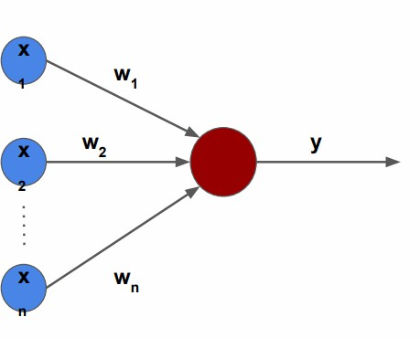
threshold value.
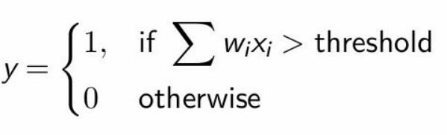

Activation functions determine whether a neuron should "activate" by processing the input data. They act as filters, allowing only relevant information to pass through. Common functions include:
  - Sigmoid: Smooth curve used for binary activations.

  - ReLU (Rectified Linear Unit): Popular in modern networks due to its simplicity and effectiveness of passing only positive values.
During training, neural networks make predictions based on the input data. When these predictions are incorrect, the network adjusts the connections (weights) between neurons. This iterative process helps the network improve over time, similar to learning from mistakes.
Neural networks come in various architectures, each tailored for specific types of tasks. Here is a quick overview:

Type | Use Case | Description
Feed-Forward Neural  Network | Standard processing  from input to output | Data flows in one direction  without looping
Convolutional Neural  Network (CNN) | Image analysis and  pattern recognition | Excels at processing grid-like  topology such as images
Recurrent Neural | Sequential data | Ideal for handling time-series or

Network (RNN) | processing (e.g., text,  audio) | sequence-dependent data

CODE:
import numpy as np
import matplotlib.pyplot as plt

# Sigmoid activation + derivative
def sigmoid(x):
return 1 / (1 + np.exp(-x))

def sigmoid_derivative(x):
return x * (1 - x)

# Multi-layer perceptron class
class MLP:
def __init__(self, input_size, hidden_size=2, lr=0.1, epochs=10000):
self.lr = lr
self.epochs = epochs
# Initialize weights randomly
self.W1 = np.random.randn(input_size, hidden_size)
self.b1 = np.zeros((1, hidden_size))
self.W2 = np.random.randn(hidden_size, 1)
self.b2 = np.zeros((1, 1))
self.loss_history = []

def train(self, X, y):
X = np.array(X)
y = np.array(y).reshape(-1, 1)

for _ in range(self.epochs):
# Forward pass
z1 = np.dot(X, self.W1) + self.b1
a1 = sigmoid(z1)
z2 = np.dot(a1, self.W2) + self.b2
a2 = sigmoid(z2)

# Compute loss (mean squared error)
loss = np.mean((y - a2) ** 2)
self.loss_history.append(loss)

# Backpropagation
error = y - a2
d_a2 = error * sigmoid_derivative(a2)

error_hidden = d_a2.dot(self.W2.T)
d_a1 = error_hidden * sigmoid_derivative(a1)

# Update weights
self.W2 += a1.T.dot(d_a2) * self.lr
self.b2 += np.sum(d_a2, axis=0, keepdims=True) * self.lr
self.W1 += X.T.dot(d_a1) * self.lr
self.b1 += np.sum(d_a1, axis=0, keepdims=True) * self.lr

# After training
predictions = self.predict(X)
print(f"{self.gate_name} Gate:")
print(f"Inputs:\n{X}\nPredictions:\n{predictions.flatten()}\nExpected:\n{y.flatten()}\n")

def predict(self, X):
X = np.array(X)
z1 = np.dot(X, self.W1) + self.b1
a1 = sigmoid(z1)
z2 = np.dot(a1, self.W2) + self.b2
a2 = sigmoid(z2)
return np.round(a2)

def plot_loss(self):
plt.plot(self.loss_history, label=self.gate_name)
plt.xlabel("Epochs")
plt.ylabel("Loss")
plt.title(f"Training Loss Curve - {self.gate_name}")
plt.legend()
plt.show()

def set_gate_name(self, name):
self.gate_name = name

# Visualization for 2-input gates or bar plot for NOT
def plot_gate(self, X, y):
X = np.array(X)
y = np.array(y).reshape(-1,1)

if X.shape[1] == 2: # 2-input gates
x_min, x_max = X[:,0].min() - 0.5, X[:,0].max() + 0.5
y_min, y_max = X[:,1].min() - 0.5, X[:,1].max() + 0.5
xx, yy = np.meshgrid(np.arange(x_min, x_max, 0.01),
np.arange(y_min, y_max, 0.01))
grid_points = np.c_[xx.ravel(), yy.ravel()]
Z = self.predict(grid_points).reshape(xx.shape)

plt.contourf(xx, yy, Z, alpha=0.4, cmap=plt.cm.RdYlBu)
plt.scatter(X[:,0], X[:,1], c=y[:,0], s=100, edgecolors='k', cmap=plt.cm.RdYlBu)
plt.title(f"{self.gate_name} Gate Decision Boundary")
plt.xlabel("Input 1")
plt.ylabel("Input 2")
plt.show()
else: # NOT gate (single input)
predictions = self.predict(X)
plt.bar([0,1], predictions.flatten(), color='skyblue', alpha=0.7)
plt.scatter([0,1], y.flatten(), color='red', s=100, label='Expected')
plt.xticks([0,1])
plt.ylim(-0.1,1.1)
plt.title(f"{self.gate_name} Gate Predictions")
plt.ylabel("Output")
plt.legend()
plt.show()

# ------------------- TRAIN AND VISUALIZE ALL LOGIC GATES -------------------

gates = {
"AND": {"X": [[0,0],[0,1],[1,0],[1,1]], "y": [0,0,0,1]},
"OR": {"X": [[0,0],[0,1],[1,0],[1,1]], "y": [0,1,1,1]},
"XOR": {"X": [[0,0],[0,1],[1,0],[1,1]], "y": [0,1,1,0]},
"NOT": {"X": [[0],[1]], "y": [1,0]}
}

for gate_name, data in gates.items():
input_size = len(data["X"][0])
hidden_size = 4 if gate_name == "XOR" else 3 # XOR needs more neurons
mlp = MLP(input_size=input_size, hidden_size=hidden_size, epochs=10000, lr=0.1)
mlp.set_gate_name(gate_name)
mlp.train(data["X"], data["y"])
mlp.plot_loss()
mlp.plot_gate(data["X"], data["y"])

OUTPUT:
AND Gate:
Inputs:
[[0 0]
[0 1]
[1 0]
[1 1]]
Predictions:
[0. 0. 0. 1.]
Expected:
[0 0 0 1]

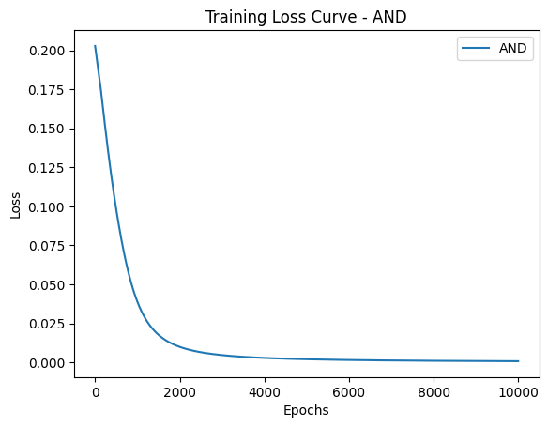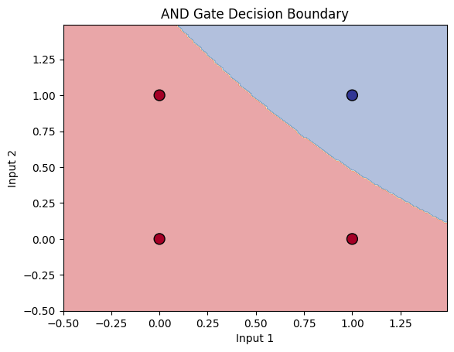

OR Gate:
Inputs:
[[0 0]
[0 1]
[1 0]
[1 1]]
Predictions:
[0. 1. 1. 1.]
Expected:
[0 1 1 1]

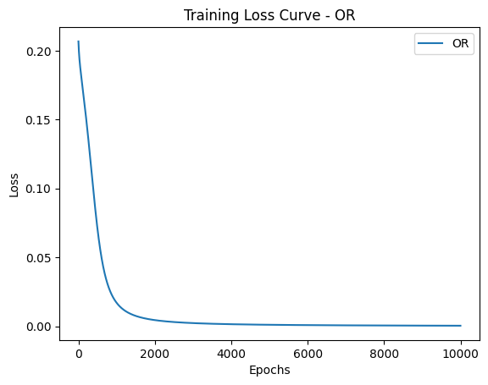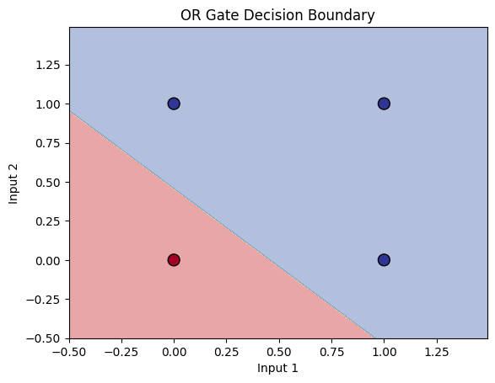

XOR Gate:
Inputs:
[[0 0]
[0 1]
[1 0]
[1 1]]
Predictions:
[0. 1. 1. 0.]
Expected:
[0 1 1 0]

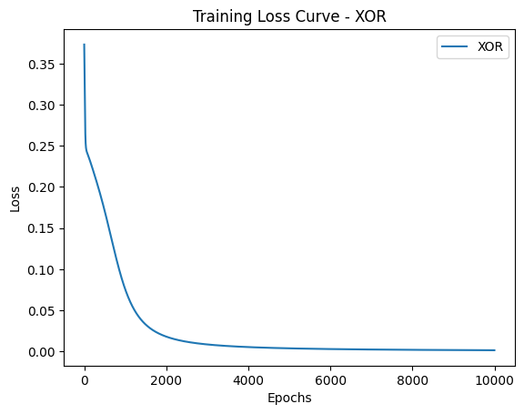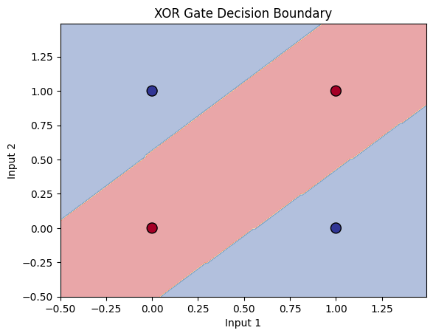

NOT Gate:
Inputs:
[[0]
[1]]
Predictions:
[1. 0.]
Expected:
[1 0]

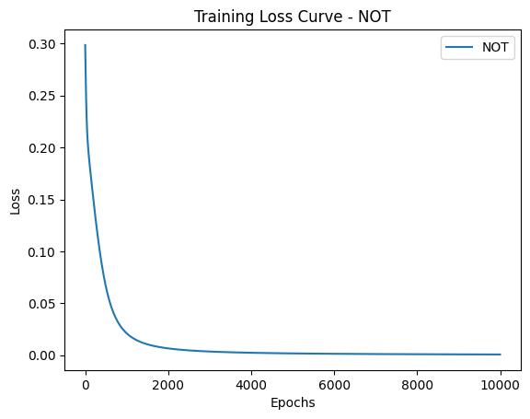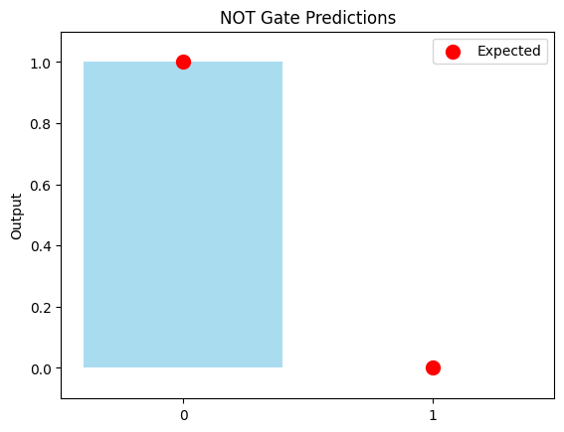

CONCLUSION:

This experiment shows that simple neural networks can learn to behave like digital logic gates. Linearly separable gates like AND, OR, and NOT are learned easily with a single hidden layer. XOR, which is not linearly separable, requires more hidden neurons — proving that multi-layer networks can solve problems a single-layer perceptron cannot. The loss curves and decision boundaries confirm that the network successfully learns the correct truth tables through training. Overall, this demonstrates how neural networks can approximate logical functions by adjusting weights through backpropagation.

